DEPARTMENT OF COMPUTER ENGINEERING
Name | Ms. Prarthana Madan Modak | 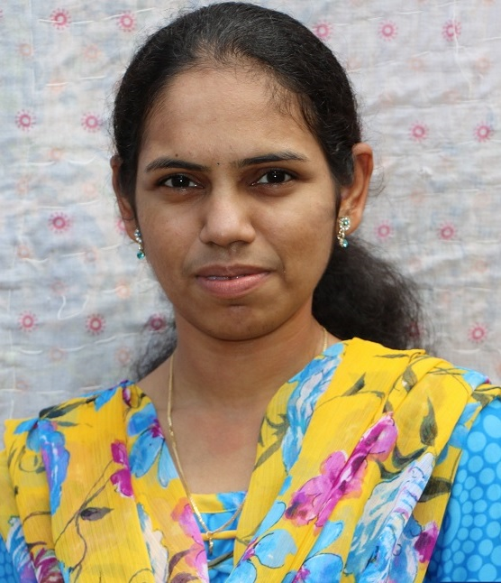
Designation | Asst Prof
Date of Birth | 6th January 1987
Highest Qualification | M. E. (Appearing ) B.E.
Specialisation | Computer Engg.
Teaching experience | 04 Years
Industrial Experience | Nil
Email id | prarthanamodak@gmail.com
Date of joining | 19/07/2010
No .of Papers presented/published (National conferences) | 1
Details | Neurophone : A DSP Based Brain-Mobile Phone Interface using a Wireless EEG Headset
No. of Papers presented/published  (International conferences) | Nil
Details | -
No. of seminars | Nil
Details | -
No. of STTP/Workshops | 0
Details | 1.ISTE Workshop on Database Management Systems (2-weeks)  2. STTP on PYLONS at SSPM college of Engg. Kankavali (1-week)  3. Software Architecture Design Patterns : Concept & implementations (1-week)  4. Software Development Techniques & Research Methodology (2-week)  5. STTP on cloud computing (1-week)
No.of projects guided at UG level | 6
Details | 1. Network Intrusion Detection System using Genetic Algorithm  (2010-11)  2. Face Recognition using FACE-ARG Matching (2011-12)  3. Wormhole Attack Prevention in Mobile Adhoc Network (2012-13)  4. Beyond Text QA: Multimedia Answer Generation by Harvesting Web Information(2013-14)  5. Secure Authentication Using Click Draw based Graphical Password Scheme(2013-14)  6. New Hand Gesture Recognition Method for Mouse Operations (2013-14)
Membership in Professional Bodies | -
Research / Sponsored / Consultancy Projects | Nil
Awards / Honours / Prizes | Nil
No.of Books published | Nil
Details | -

